In regard to the what factors have the highest effect on the adoption rate, we have the following findings:

1. A rolling window calculation was used to determine that 13.35% of users are adopted users
2. Besides an initial drop off from at the start of the service, creation time had minimal effect.
3. Sign-up via google authentication or via a guest increases likelihood of adoption by +3%, while sign-up via personal project decreases likelihood by +5%.
4. The marketing drip, mailing list and being invited by a user appear to have little to no effect.
5. Number of visits over a user’s lifetime seem to be a very good indicator with an inflection point at approx. 8 visits (see histogram below showing ratio of users adopted vs not at different visit counts).

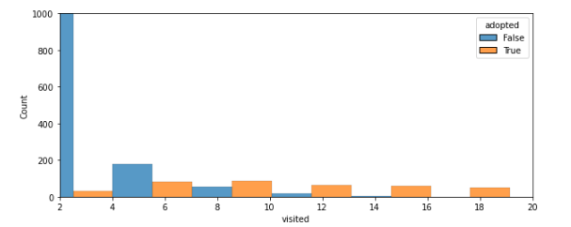

1. Duration since last session is also a good indicator with users accessing the service in the last month being much more likely to be adopted users. The below graph ratio of adopted vs unadopted users at different days since last session.

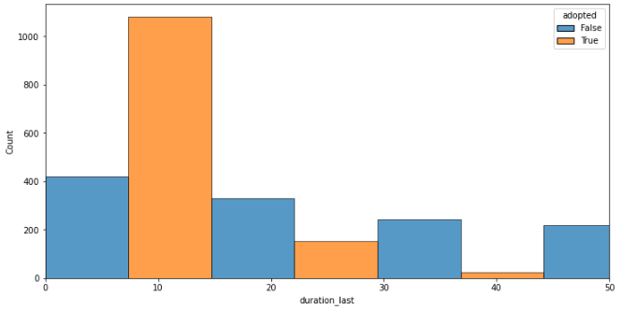

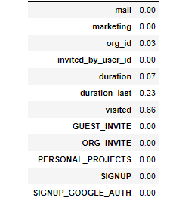

1. We also modeled the given data with a Random Forest Classifier and it’s learned feature importances also show benefit from duration from last visit and number of visits.